Advanced Engineering Mathematics, by Erwin Kreyszig 10th. Ed.
Problem Set 3.1
No. 1
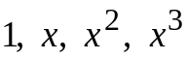
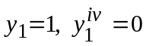
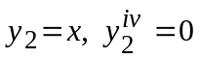
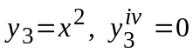
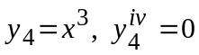
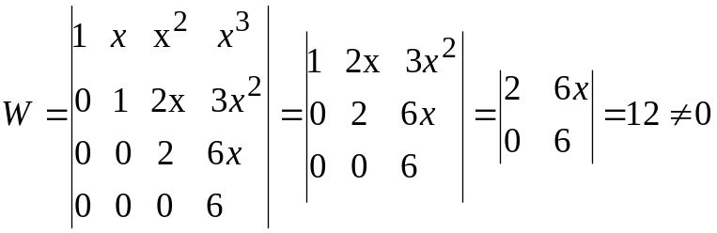
No. 2
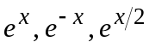
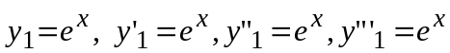
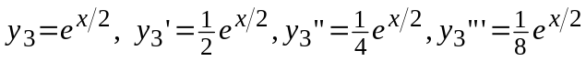
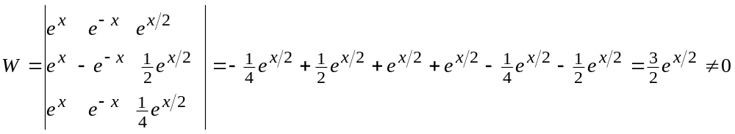
No. 3
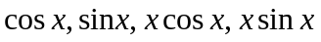
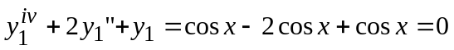
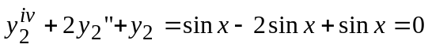
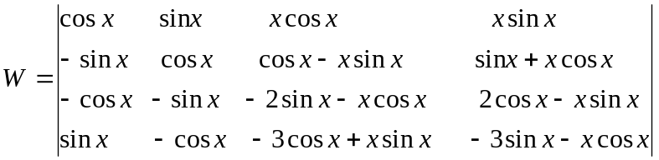
Row 1 added to Row 3
Row 2 added to Row 4
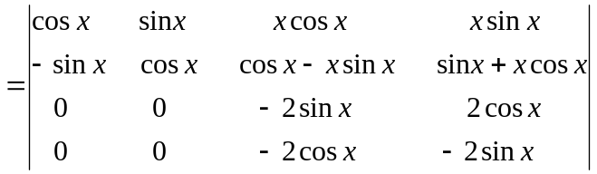
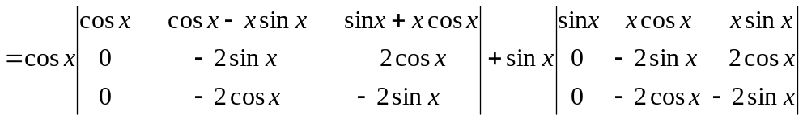
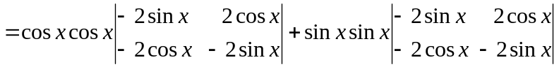
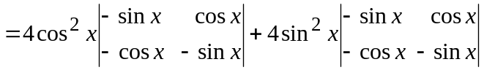
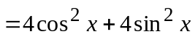
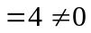
No. 4
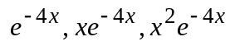
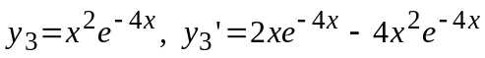
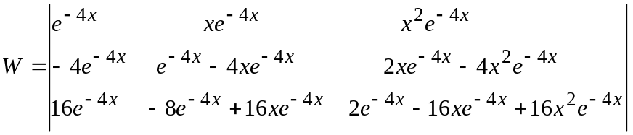
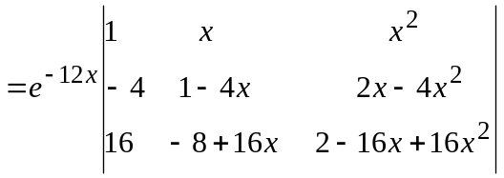
Row1×4+Row2
Row1×(-16)+Row3
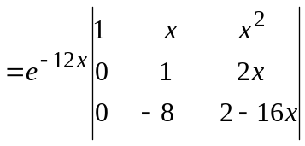
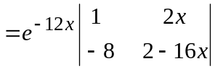
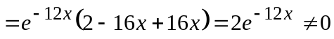
No. 5
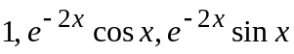
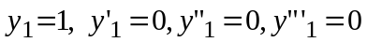
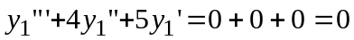
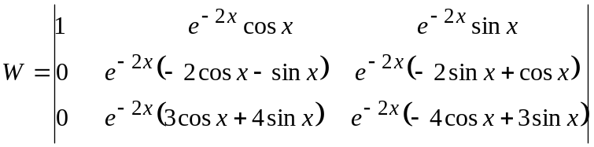
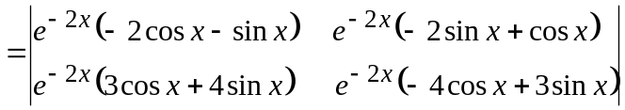
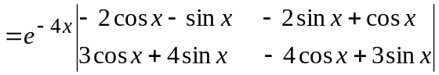
Row1×4+Row2
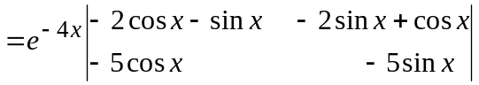
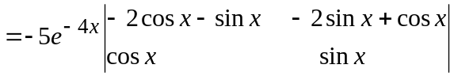
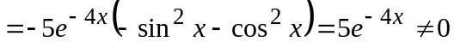

No. 6
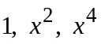
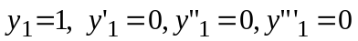
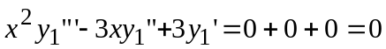
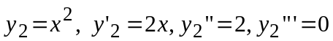
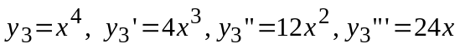
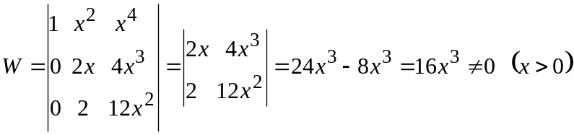
No. 7
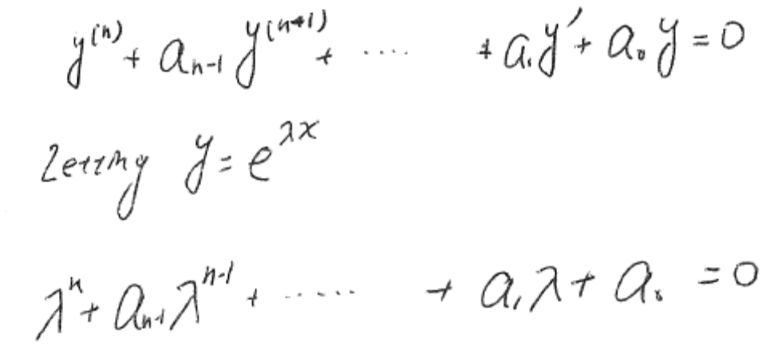
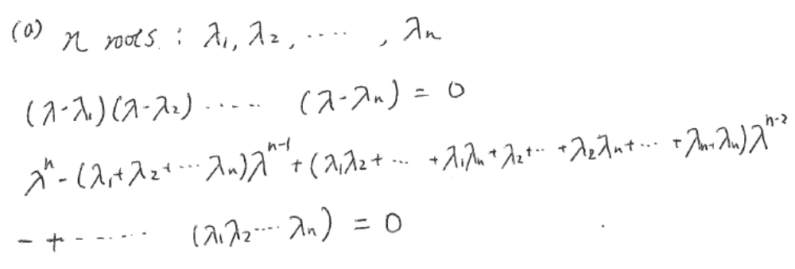
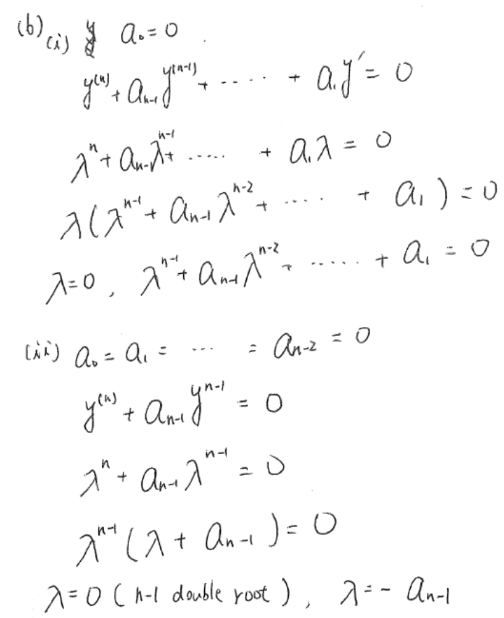
No. 8
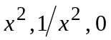
If 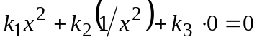, 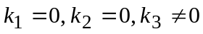
Linearly dependent.
No. 9
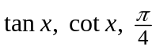
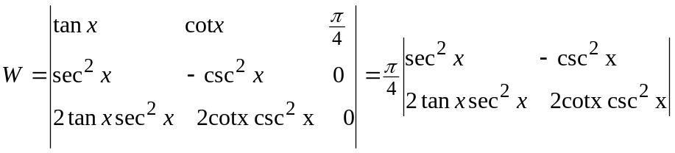
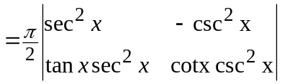
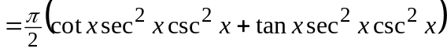
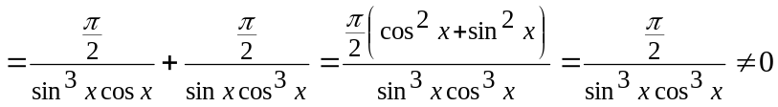
Linearly independent at any point.
No.10
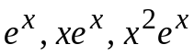
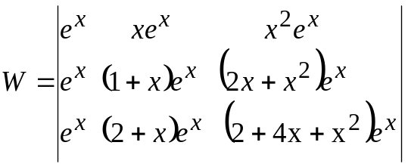
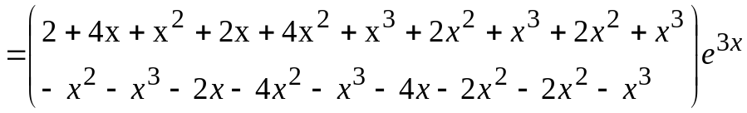
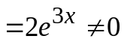
Linearly independent.
No.11
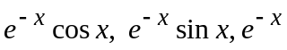
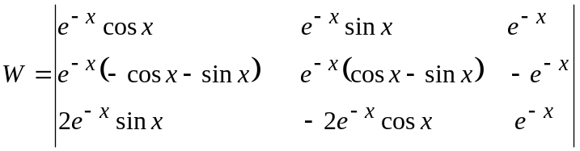
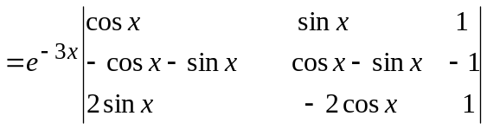
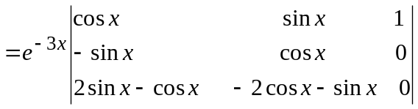
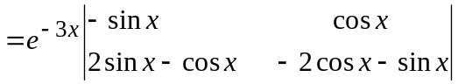
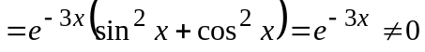
Linearly independent.

No. 12
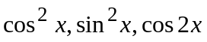
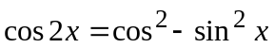
Linearly dependent.
No. 13
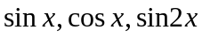
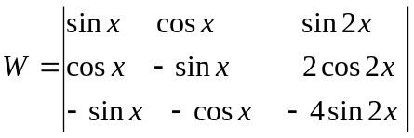
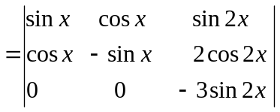
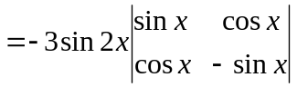
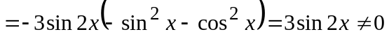
Linearly independent.
No. 14
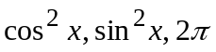
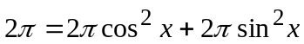
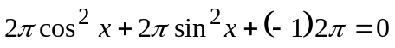
Linearly dependent.
No. 15
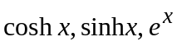
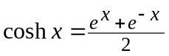
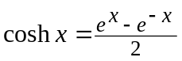
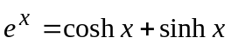
Linearly dependent.
No. 16
